National Lutheran School Accreditation
Cumulative Annual Report
Revised February 2019

<INSERT SCHOOL NAME>
<INSERT CITY, STATE>

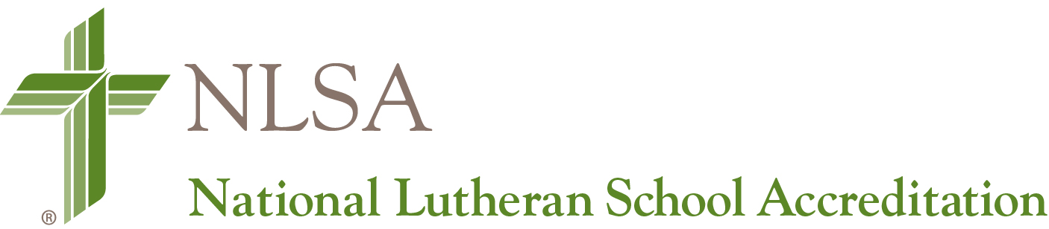
PART I: SCHOOL INFORMATION

School Name:
Address:
City / State / ZIP:

School Administrator Name:
School Administrator Phone Number:
School Administrator Email Address:

LCMS District:

Co-Accredited By (If Applicable):

WASC
AdvancED

Date of Most Recent NLSA Site Visit:

Report is for Year (Indicate One):

Year One
Year Two
Year Three
Year Four
Year Five (WASC Only)

Administrator Signature: ______________________________________ Date: _____________

Governing Authority Signature: _________________________________ Date: _____________

This report is due in the PSD district office no later than April 15. The District Accreditation Committee will review by June 15 and submit any findings to the National Accreditation Commission in July.

PART II: RECOMMENDATION REPORT
FOR INDICATORS:

- List Any Major Deficiencies/Critical Areas for Follow-up First
- List all Recommendations Made by the Visiting Team and Target School Year to be Addressed
- List and Date Actions Taken During this School Year as well as Actions Taken in Previous Years of Accreditation Cycle
- Add an additional table to address your School Improvement Plan/On-going Improvement Plan.
- Be sure to clearly label and upload all evidence into your school’s shared Google accreditation file.

NOTE: To add lines to the table for more concerns and recommendations, put the cursor in the bottom right field and type the “tab” key.

Standard  and  Indicator Number | Validation Team Concern and Recommendation | Target  School  Year | School  Year  Addressed | Action Taken

